Trifunctional Phosphatidylinositol 3,4,5-trisphosphate
PI(3,4,5)P₃

Structure
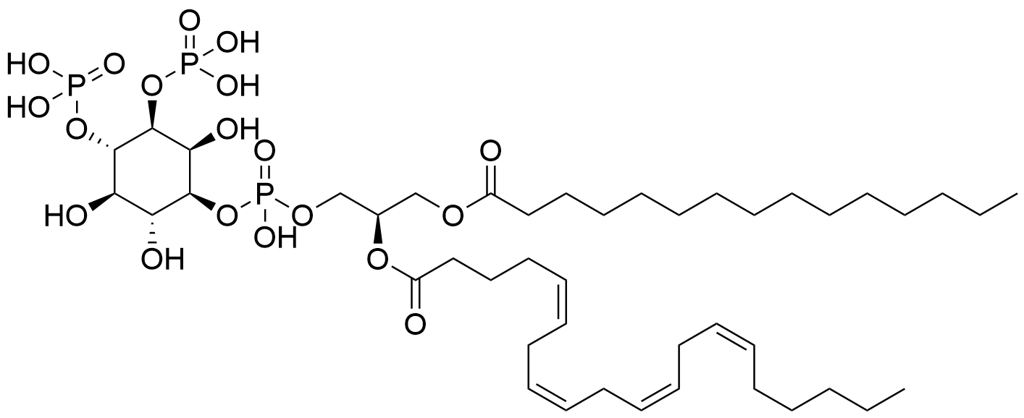
Native PI(3,4,5)P₃.

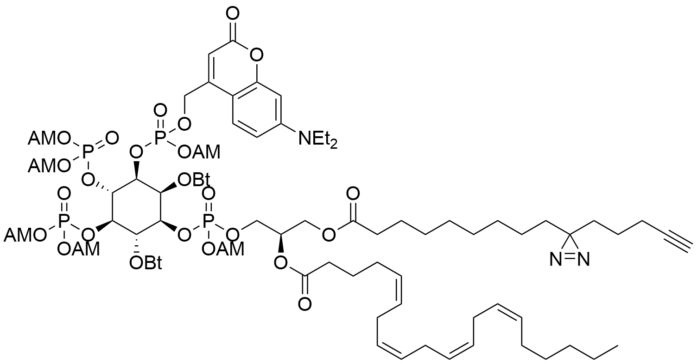
Trifunctional PI(3,4,5)P₃.

Chemical structures drawn by Berit Blume.

Protein interactome

